**Docker Learning for Automation Testing**

1. To Check Docker on your machine

Step-1: Open CMD and enter below command.

***docker –version***

*C:\Users\etikalaj>docker --version*

*Docker version 20.10.2, build 2291f61*

This command tells you the version of docker

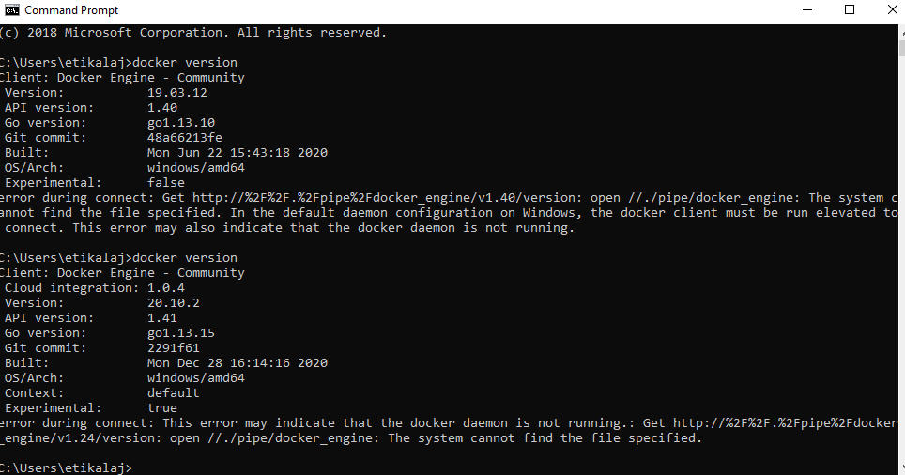

1. **DockerHub**

Step-1: Create and account for docker hub

Step-2: Login

Step-3: search for chrome standalone version [ this is the image which we need to pull from docker hub]

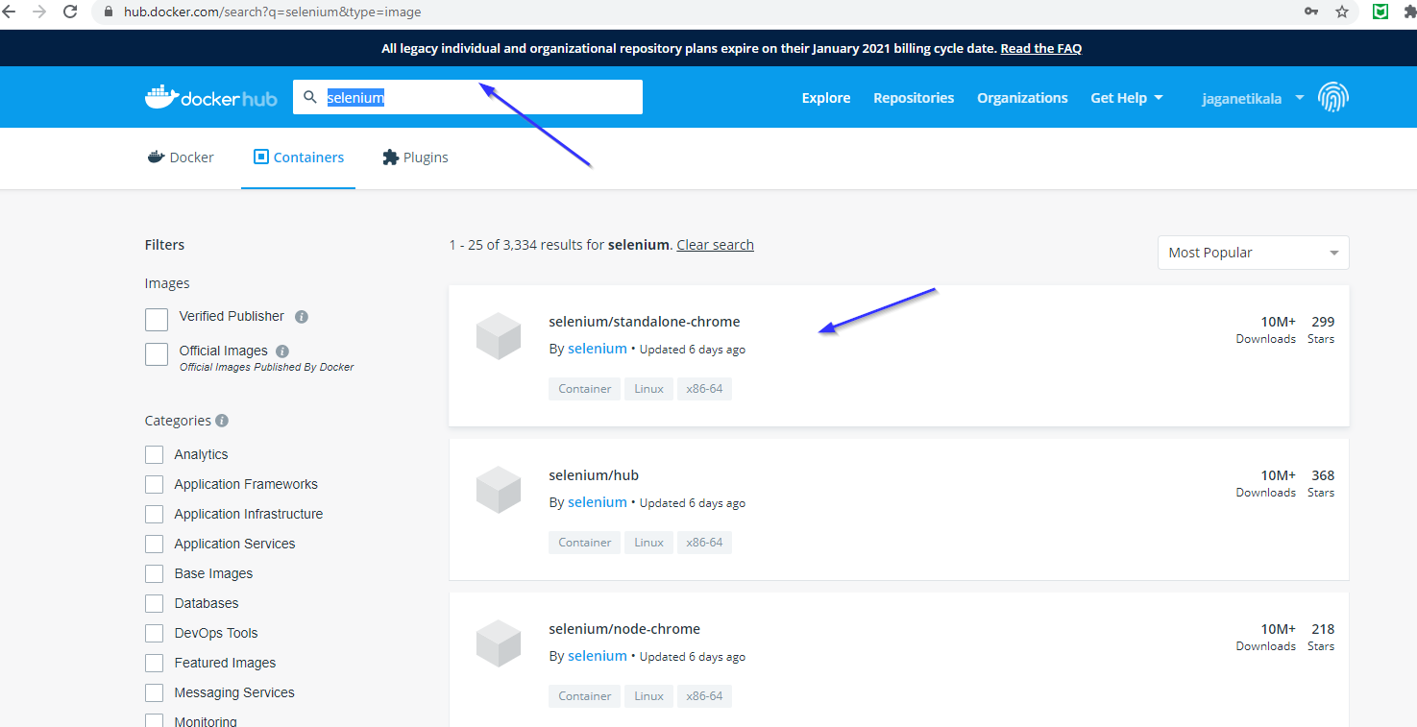

Copy the command from below screen

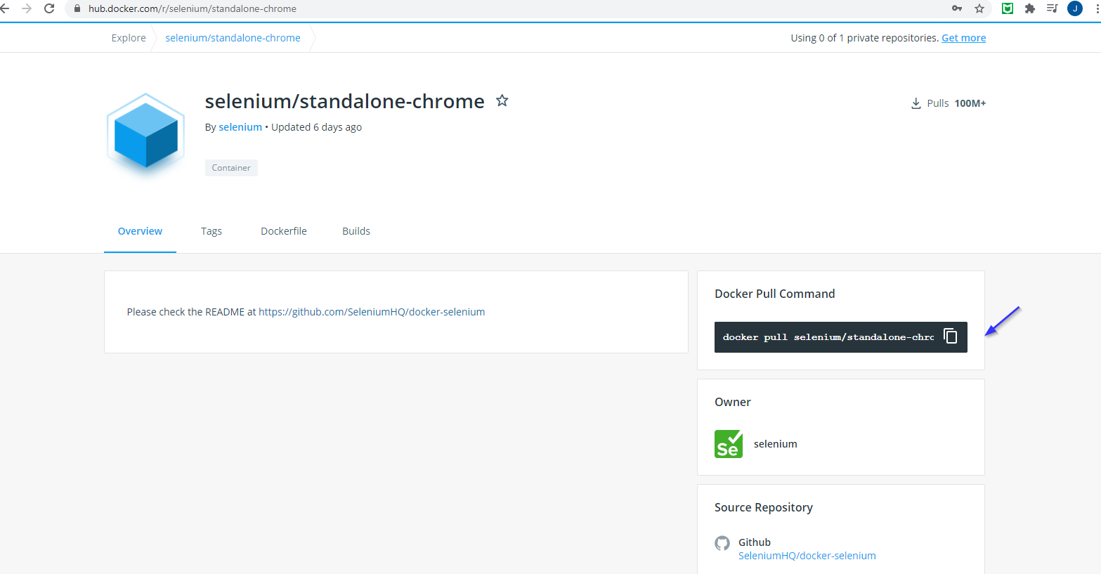

1. **Logins issue sorting**

On your local machine, If for some reason your login credentials are not working in cmd then use below steps to login:



*C:\Users\etikalaj>docker login*

*Authenticating with existing credentials...*

*Stored credentials invalid or expired*

*Login with your Docker ID to push and pull images from Docker Hub. If you don't have a Docker ID, head over to https://hub.docker.com to create one.*

*Username (jaganetikala): jaganetikala*

*Password:*

*Login Succeeded*

1. **Chrome image download**

Now use below command in cmd to pull the image:

Note: Here “latest”, means the latest image will be downloaded

***docker pull selenium/standalone-chrome:latest***

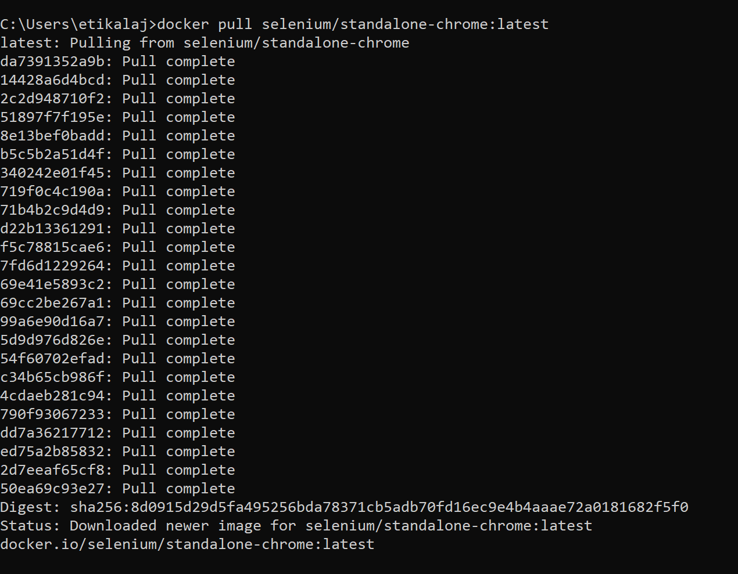

1. **Check downloaded docker image**

In cmd type “docker images” , then you can see the list of images present in your machine

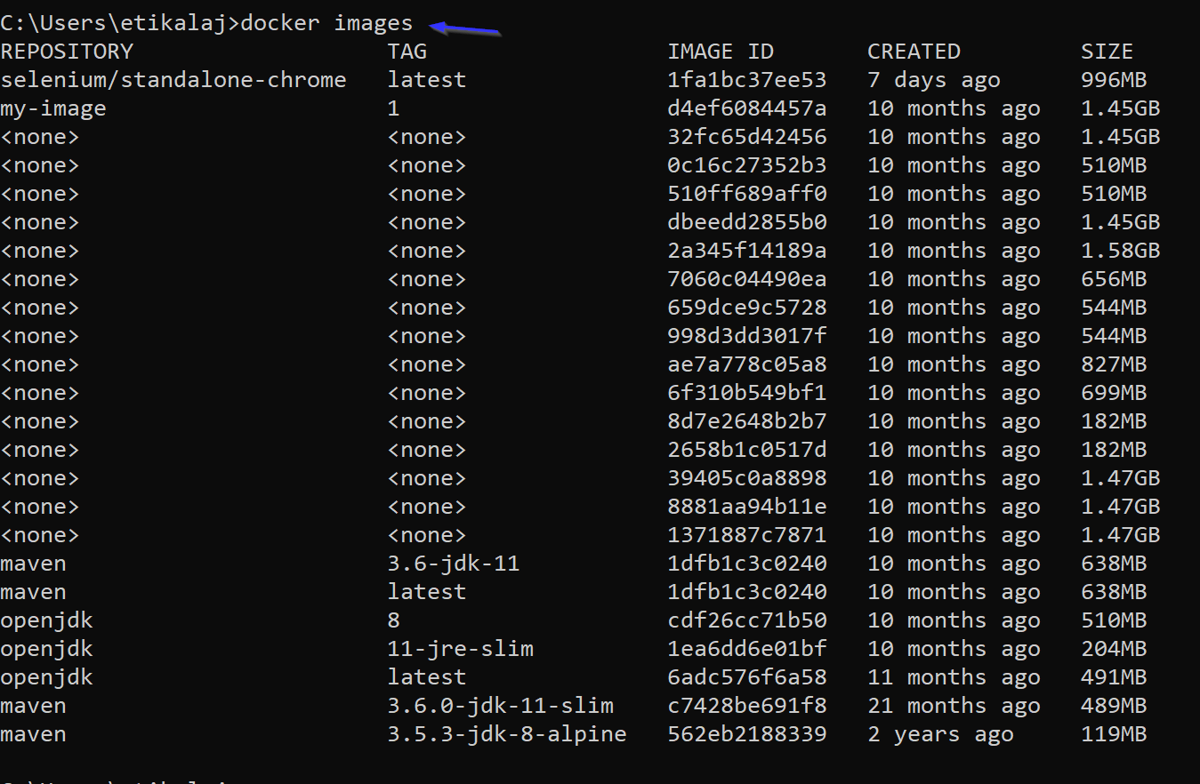

1. **GitHub for selenium**

Here is the github location (<https://github.com/SeleniumHQ/docker-selenium>)

From github copy below mentioned command to run the image pulled from docker hub

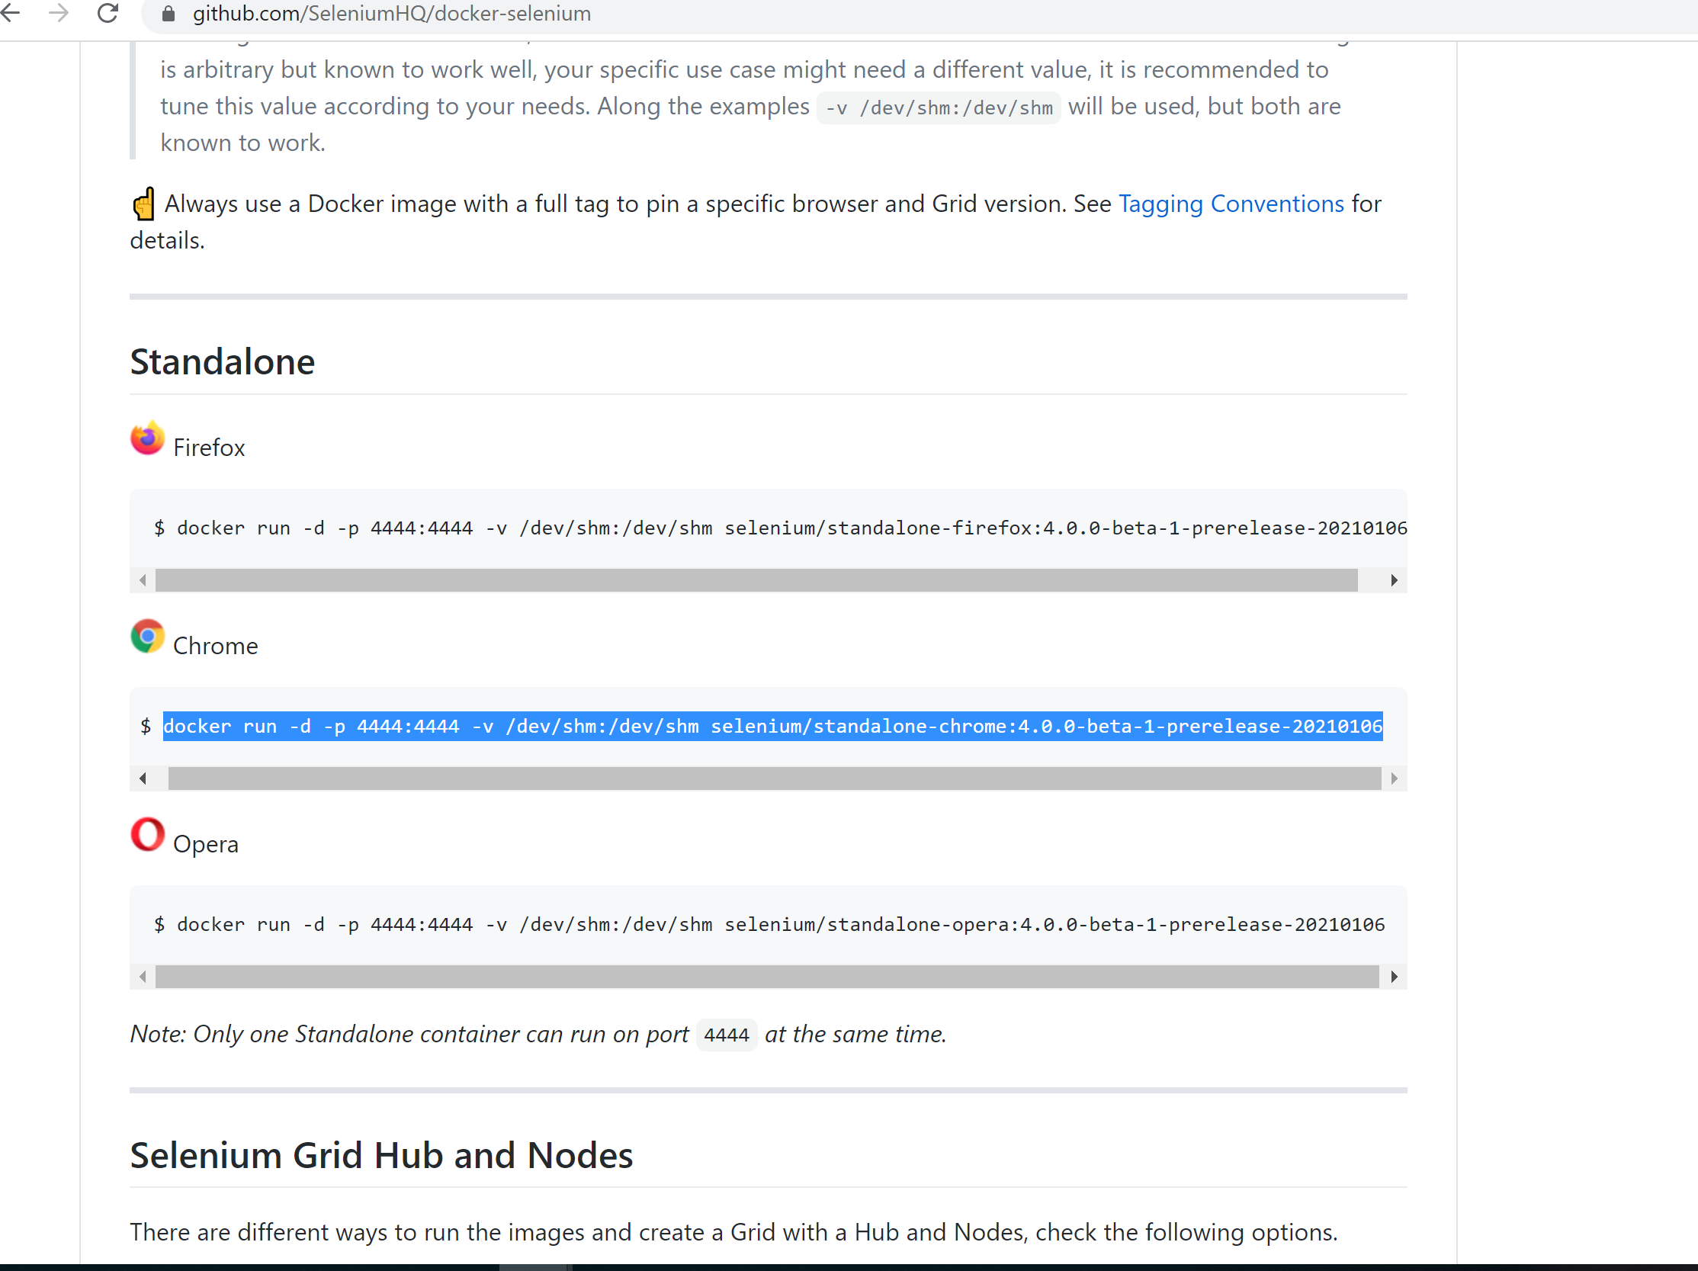

1. **Run image**

*docker run -d -p 4444:4444 -v /dev/shm:/dev/shm selenium/standalone-chrome:latest*

before running the image lets check for any container available by running below command

from below command we see no containers running

*C:\Users\etikalaj>docker ps*

*CONTAINER ID IMAGE COMMAND CREATED STATUS PORTS NAMES*

Now lets run our selenium-chorme image

*C:\Users\etikalaj>docker run -d -p 4444:4444 -v /dev/shm:/dev/shm selenium/standalone-chrome:latest*

*217721ff97fe52bd51ffdf79d75abbadccd398d7773615323e6d1df633c8ead6*

Now to check for the newly created container run below command:

*C:\Users\etikalaj>docker ps*

*CONTAINER ID IMAGE COMMAND CREATED STATUS PORTS NAMES*

*217721ff97fe selenium/standalone-chrome:latest "/opt/bin/entry_poin…" 32 seconds ago Up 31 seconds 0.0.0.0:4444->4444/tcp cool_blackwell*

1. **We created container, now we have to create selenium tests are run inside container, lets see those steps**

Step -1: Create a **Maven** project in eclipse.

Step-2: Create a test as below

package com.Nav.test;

import static org.junit.Assert.assertTrue;

import java.net.URL;

import java.net.MalformedURLException;

import org.junit.Test;

import org.openqa.selenium.remote.DesiredCapabilities;

import org.openqa.selenium.remote.RemoteWebDriver;

public class Navigate_Test

{

@Test

public void Nav() throws MalformedURLException {

**// DesiredCapabilities -🡪 this tells which browser we are going to execute our code on**

DesiredCapabilities dc = DesiredCapabilities.chrome();

**//Selenium hub url**

URL url =new URL("http://localhost:4444/wd/hub");

**//RemoteWebDriver 🡪 we use this remote driver as we are running on a docker container**

RemoteWebDriver driver = new RemoteWebDriver(url,dc);

driver.get("https://www.tab.com.au/");

System.out.println(driver.getTitle());

}

}